**SCHOOL OF COMPUTER ENGINEERING**

**KIIT DEEMED TO BE UNIVERSITY**

**CS-29002**

**Operating Systems Laboratory**

|  |  |  |  |
| --- | --- | --- | --- |
| **Lecture:** | 0 | **Internal Assessment Marks:** | 60 |
| **Tutorial:** | 0 | **End Term Marks:** | 40 |
| **Practical:** | 2 Hrs/Week | **Credits:** | 1 |
| **Faculty:** | **Section:** |  |  |

**Software Requirements**

* GCC compiler
* Unix platform (Currently used Ubuntu12.04 LTS)

**Hardware Requirements**

* Processor: 386 and above
* RAM: 32 MB and above

**Course objectives**

The objective of this lab is to give an idea about different components of operating system and their interactions happened in an operating system. Specifically, in this course, we mostly focus on the UNIX operating system, where student can get the practical understanding about how to manage the processes with respect to process creation, process communication process synchronization, threading, manage file, etc.

**List of Sample experiments**

Lab 1:

* UNIX commands
* How to write and execute a shell program
* Expression evaluation and command line arguments
* Assignments

1. Verify different UNIX commands (syntax to use with options)

Some list (but not limited): basename, mkdir, ls, echo, read, expr, kill, who, which, date, users, vim, touch, bash, cat, hostname, rm, mv, chmod, top and so on.

1. Write a shell program to add two numbers using command line argument.

$ sh sum.sh 12 14

Sum is: 26

1. Write a shell program to convert distance into meter, cm and km.

$ sh distance.sh

Enter distance in cm: 15000

1 km 550 mt 0 cm

1. Write a shell script to extract the data from the date command, and display the result in different format.(if the date command gives “Thu Jan 2 14:21:54 IST 2014” then display the result in “2/Jan/2014/14.21”)

**Vary the date commend with different options.**

Lab 2:

* logical operator, relational operator used in bash shell
* How to write down the conditional statements in bash shell using logical and relational operator?
* Different control statements (if, elif, case, while, for)
* Assignments
  + Write a shell program to find whether a given year is a leap year or not.

$ sh leapyear.sh

Input (year): 2024

Output: "2024 is leap year"

* + Write a shell program to find greatest among three numbers.

$ sh greatest.sh 8 3 9

9 is greatest

* + Write a shell program to display the prime number between 1 and hundred.

$ sh prime.sh

**2, 3, 5, 7, 11, 13, 17, 19, 23, 29, 31, 37, 41, 43, 47, 53, 59, 61, 67, 71, 73, 79, 83, 89, 97**

* + Execute the “ps -ef” and “ps -ux” command. Write a shell program that takes the output of these two commands and display the detail about a process whose parent id is 2. The detail about a process will be shown as it is shown during the execution of “ps -ux” command.

$ sh process.sh

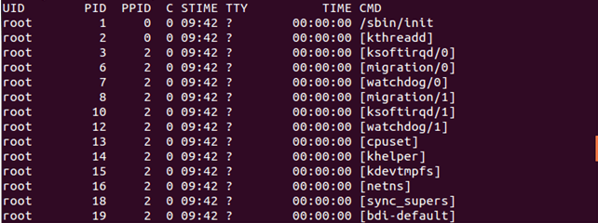 Enter process ID: 2





* + Write a shell script to extract the data from the date command, and display the result in numerical form with 12 hour format. (if the date command gives “Thu Jan 2 14:21:54 IST 2014” then display the result in “02/01/2014/2:21:54 PM”)

-------> will be added by Prof. Prasenjit MaitySir.

* + Let a directory present in the home directory called “XYZ” that consists of few files and directories. Write a shell script to move all the files present in the “XYZ” directory to a subdirectory called “MyFile” and all the subdirectories present in the “XYZ” directory to a subdirectory called “MyDir”.

--------> will be added by Prof. Saurabh Bilgaiyan Sir.

Lab 3:

* Different Loop statements (while, for, until, case)
* Assignments
  + Write a shell script to reverse a given integer.

$ sh reverse.sh

Enter a number: 253

Reverse number: 352

* + Write a shell script to verify whether the given string is a palindrome or not.

$ sh palindrome.sh

Enter a number: 253

Reverse number: 352

Number is not palindrome

* + Write a shell script to find the following

1. Home directory 2. Bash version 3. Host name 4. current directory 5. exit

$ sh menu.sh

1. Home directory 2. Bash version 3. Host name 4. Current directory 5. exit

Enter your choice: 2

4.4.19(1)-release

* + Write a shell program which takes maximum 8 integer type arguments through command line and do the following operation:
    - If the first argument/last result (a) is divisible by send argument (b) then new result=a/b
    - Else If (a%b != 0) and b is divisible by 5 then new result=a*b
    - Else if (a>b) then new result=a-b
    - Else new result=a+b

-----> Will be added by Prof. Mainak Bandyopadhyay Sir.

Lab 4:

* Implementation of array in shell script.
* Assignments
  + Write a shell script that will take 3 file names as command line argument and concatenate first two files line by line and store the result in third file.

-----> Will be added by Prof. Murari Mandal Sir.

* + Write a shell script that will store all the files in different directory named as x_1, x_2,… where maximum size of each directory is X.

-----> Will be added by Prof. Namita Panda Maam.

Lab 5:

* Discuss a generalized way to design the CPU scheduling algorithm
* Assignments
  + FCFS algorithm implementation in C using structure / linked list

Enter the number of processes: 3

Enter process id of all the processes: 1 2 3

Enter burst time of all the processes: 5 11 11

Enter arrival time of all the processes: 0 0 0

Process ID Burst Time Waiting Time TurnAround Time Arrival

1 5 0 5 0

2 11 5 16 0

3 11 16 27 0

Avg. waiting time= 7.000000

Avg. turnaround time= 16.000000

* **Home assignments**
  + SJF(non-preemptive) algorithm implementation in C

Lab 6:

* Discuss a generalized way to implement preemptive CPU scheduling algorithms
* Assignments
  + Preemptive SJF algorithm implementation in C using structure / linked list

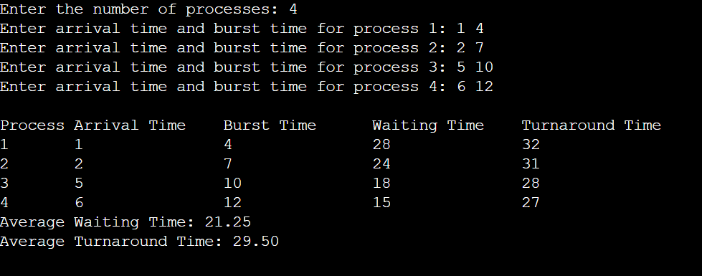

* **Home assignments**
  + Round robin algorithm implementation in C

Lab 7:

* Discuss basics of round robin algorithm implementation
* How to create a processes using fork system call
* Use of wait function
* Assignments
  + Create different process tree using fork system call

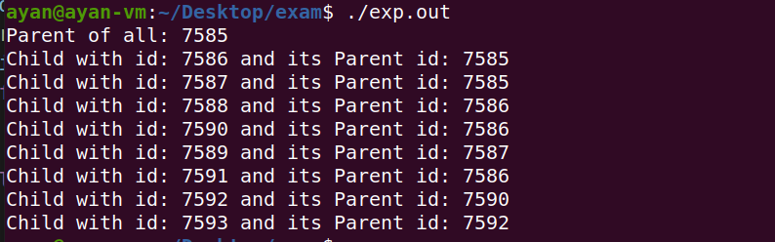

* + Write a program where a process waits for all its child processes

2.Hello from parent

1.Hello from child

Bye

3.Child has terminated

Bye

Bye

1. Hello from child

Bye

1. Hello from parent or

3. Child has terminated

Bye

**Note**: “child has terminated”--- this sentence does not print before “1.Hello from child”because of wait.

Lab 8:

* Discuss about process communication using pipe
  + how to create pipe between two processes
  + What is the use dup function? How it can be utilized in pipe line commands
* Assignments
  + Write a program that creates n level process structure where each level consists of exactly one process. Here every parent process makes some modification to the original message and sends it to its child and this process repeats till it reached at the last child in the process tree.

-----> Will be added by Prof. Manas Ranjan Lenka Sir.

* **Home assignment**
  + Write a program to create a ring topology among n number of process and message has to be passed using the pipe in clock wise or anti clock wise direction.

Lab 9:

* Discuss the thread creation using pthread library
* Assignments
  + Write a program to create two threads where one thread adds half of the element from the beginning of the array and another thread add half of the element from the end of the array. And at the end main process shows the sum of all the elements in the given array.

-----> Will be added by Prof. Manas Ranjan Lenka Sir.

* + Write a program to implement the merge sort using multiple threads

-----> Will be added by Prof. Manas Ranjan Lenka Sir.

Lab 10:

* Discuss different functions related to Mutex lock using POSIX library
* Discuss different functions related to conditional variable using POSIX library
* Discuss different functions related to semaphore using POSIX library
* Assignment
  + Write a program for reader-writer problem using lock.

Enter the number of readers:2

1 reader is inside

Writer is trying to enter

2 reader is inside

Writer is trying to enter

2 Reader is leaving

1 Reader is leaving

Writer has entered

Writer is leaving

Writer has entered

Writer is leaving

* + Write a program to implement critical section using semaphore

**Home Assignments**:

* Producer consumer problem using semaphore
* Producer consumer problem using mutex lock
* Dining philosophers problem using semaphore
* Dining philosophers problem using mutex lock

**Guidelines**

1. *Students should be regular and come prepared for each laboratory class.*
2. *Students should bring their lab record and practice note books to every class.*
3. *The prescribed text and reference books and class notes can be kept ready for reference if required.*
4. *Students have to complete their lab experiments in the lab and be capable to explain and show the modifications, output results as and when required by the Faculty/Lab Programmers/Teaching Assistants responsible for that lab. All these are to ensure that the students’ capability is built up to understand, debug and modify codes as per the requirements.*
5. *In case a student misses a class, it is his/her responsibility to complete the missed experiment(s).*
6. *The code written by the student should meet the following:*
7. *Program should have proper input prompt messages(****Menu Driven****) and descriptive output.*
8. *Input validation should be done (data type, range error etc.) and give appropriate error messages and suggest corrective actions.*
9. *Comment lines should be used to give Students Name, Roll No, Branch, Section, Subject, Problem Statement, describe functions, Expected Input & Output and all the key Logic.*
10. *Program should be indented properly. Variables and functions should be meaningfully named. [USE CODING STANDARDS].*
11. *Try to optimize the code wherever possible.*
12. *All programs should be verified by different values and lengthy inputs. [with minimum VALIDATIONS]*
13. *Once the experiment(s) get executed, they should show the program and results to the Faculty/Lab Programmers/Teaching Assistants responsible for that lab. and copy the same in their observation book and get signed which ensures him/her with day to day performance marks*
14. *Student should submit his/her record by/in the next lab session to ensure the lab record marks gets evaluated. Failing to do so reduces the lab record marks.*
15. *Lab examination questions need not necessarily be limited to the questions in the laboratory manual, rather it could include some variations and/or combinations of questions.*
16. *Students are strictly advised to take care of their personal belonging all the time. The University is not responsible and liable to any lost of personal belonging in the computer labs.*

**Scheme of Evaluation**

Maximum marks for Database Lab is **100**, which is divided into Continuous Internal Assessment and **End-Sem** Final Evaluations.

|  |  |
| --- | --- |
| Internal Assessment (Continuous evaluation over the semester): | **60Marks** |
| End-Tem Evaluation (At the End of the Semester): | **40 Marks** |
| Minimum Marks for passing in the Lab: | **50 Marks** |